Pregnancy among teenagers

When doing teen [surveys](https://www.care.com/c/stories/778/100-questions-to-get-to-know-your-teenager/) one question is certainly included: Do you want to have kids one day? While most respondents will answer in the affirmative, practically none plan to enter parenthood immediately, while still in their teens. The global trend is definitively towards later parenthood, but recently, reality TV has brought back teen to a wider attention.

# Teen pregnancy rates in the world

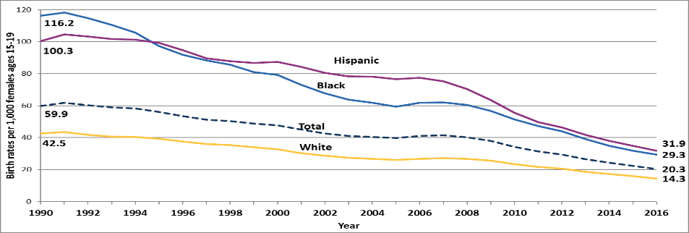Teen pregnancy rates are wildly different in the world. In Europe, British teenagers are at the top with 22 births per 1000 women. Austria is significantly lower with 12 births per 1000 women, Germany is between with 16 births per 1000 while on the hand Switzerland and Netherlands have the lowest teen pregnancy rate with 5:1000 (Switzerland) and 4:1000 (Netherlands). On the other side of the world the USA is pretty high for a first world country with 55 births per 1000 women.

Source: hhs.gov???????

The overall trend is decreasing, but in other parts of the world like many African countries the rate is still high.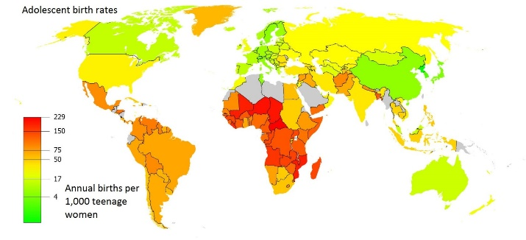

Source: bjv.at???? What is that

# Difficult for everyone

Teen pregnancy is generally a hard topic for teens, particularly for girls, many of whom are not not emotionally prepared for this burden. Much of sex education is happening early on in school or home, but they all fail to teach something really important,  
the reality of teenage parenthood and its consequences for the young parent`s school career and life decisions.

( the emotions and the desire that follow a sexual relationship.??? CONTEXT? LOGIC)

# What to do when you find out?

That makes it difficult for many girls to even fully accept that they are pregnant. Which makes it even more problematic because many of them do not visit a doctor right away. And when they do they decide to pay a visit they oftentimes get the necessary medical information too late and no longer have the option to terminate the pregnancy.

# Risks of teen pregnancy

Teen pregnancy can be harmful to both parents but especially to young mothers. Not only can emotional problems be caused, but young parents who have to take care of their children may drop out of their education, studies, etc. and find it difficult to get back on track.In developing countries, risks are even greater: Around 70.000 girls and young women die yearly because of problems with giving births. And that makes is less surprising that the main cause of death of women between 14 and 19 years commit suicide.

* Write one more paragraph….. risk of not providing adequately because teen parents are still “cvhildlike” themselves in many respects, can they provide children with what we deem necessary today?
* Effects on mothers, babies and fathers: <https://www.healthline.com/health/adolescent-pregnancy#effect-on-teen-mothers>

1 paragraph on this

* Reality on TV?

The picture that reality shows paint …….

Write a paragraph on the image projected in the media. Is it realistic?

Informed decisions

Any decision that hugely impacts your life and the lives of others, for that matter, needs to be carefully considered. Sound information and comprehensive sex education have to be provided to every teenager, no matter what their background in terms of family values, religion, school, ….. Here are some links you may find helpful:

<https://www.healthline.com/health/adolescent-pregnancy#takeaway>

………